**SUMMARY**

The purpose of this document is to provide insights and instructions on how to use the application to manage the data displayed to end users (teachers) as an administrator/moderator of the application. The person in charge of managing the data must thoroughly understands the contents of this document to be effective while managing the application.

**TABLE OF CONTENTS**

1. **Types Of Content**
   1. **Videos**
   2. **Laboratories**
   3. **Pop Quizzes**
   4. **3D Models**
   5. **Mindmaps**
2. **Uploading Data**

**TYPES OF CONTENT**

**VIDEOS**

The videos that are needed to be displayed inside the application should be

converted into ‘.webm’ (web media).

**Reason**

* The web view module is unable to display .mp4 format videos correctly. The only format it correctly supports is webm. So it is out of **NECESSITY** to convert them
* Although the native video player supports all kinds of video formats, it might be in our best interest to be **CONSISTENT** when it comes to formats we would be using.

Also, there is a need for you to adjust the framerate and file size of the videos as some of them have a huge file size with absolute no apparent difference when compared to its smaller file size counter part.

So here are the pre-requisite and steps you have to take in order to convert videos into .webm format.

**PRE-REQUISITE**

* Shotcut

Although there are many other softwares, I found out that Shotcut is extremely versatile when it comes to video editing on Windows devices. Hence, we will be using Shotcut for all operations related to videos

**STEPS NEED TO BE TAKEN**

1. Download Shotcut

Shotcut is an open-source software. So we don’t have to worry about any cost related problems and just focused on our job.

You can download Shotcut software directly from this [link](https://github.com/mltframework/shotcut/releases/download/v22.06.23/shotcut-win64-220623.exe). After downloading install the application as per instruction.

1. Using Shotcut

I wouldn’t be answering every single thing related with Shotcut as most of them are absolutely un-necessary. So I will only be focusing on the part that we will need most of the time.

* To start off

When you open Shotcut for the first time, the screen you would be seeing is this

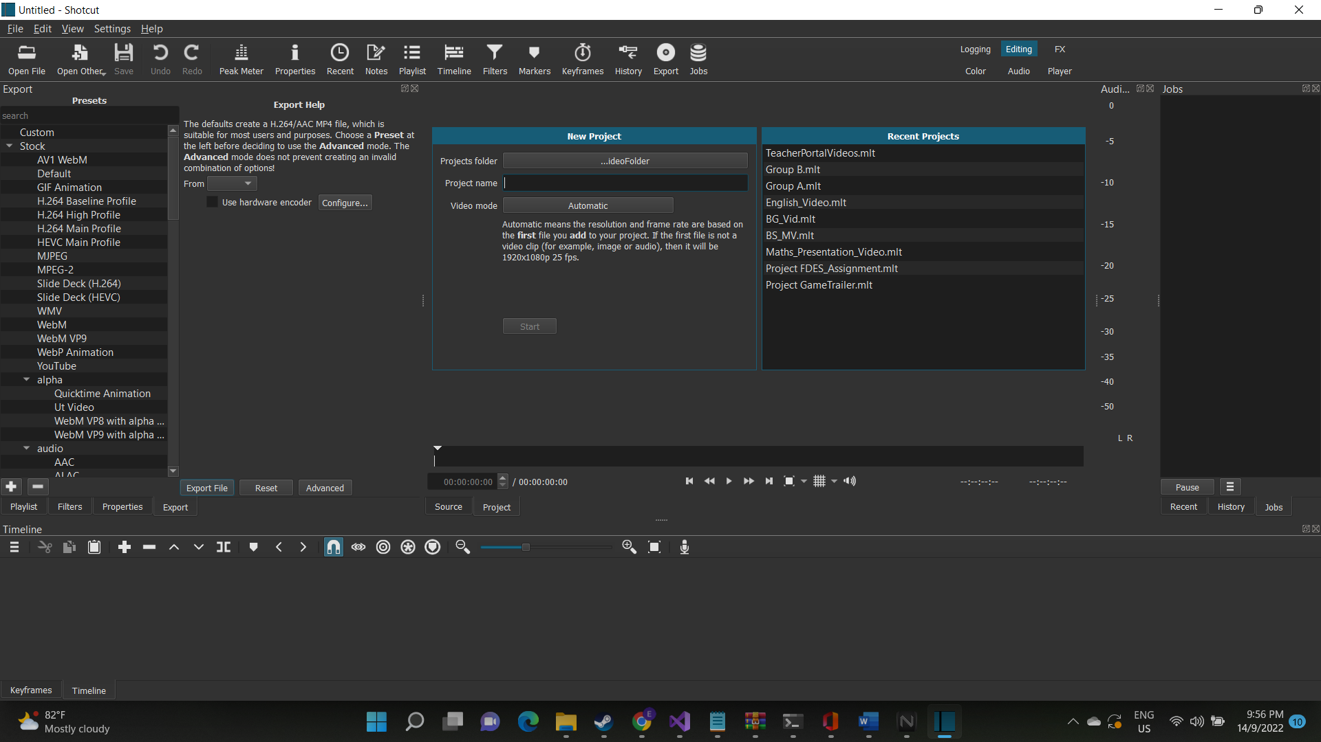

Of course, with no Recent Projects tab.

First, you would like to input the project name and click start.  
 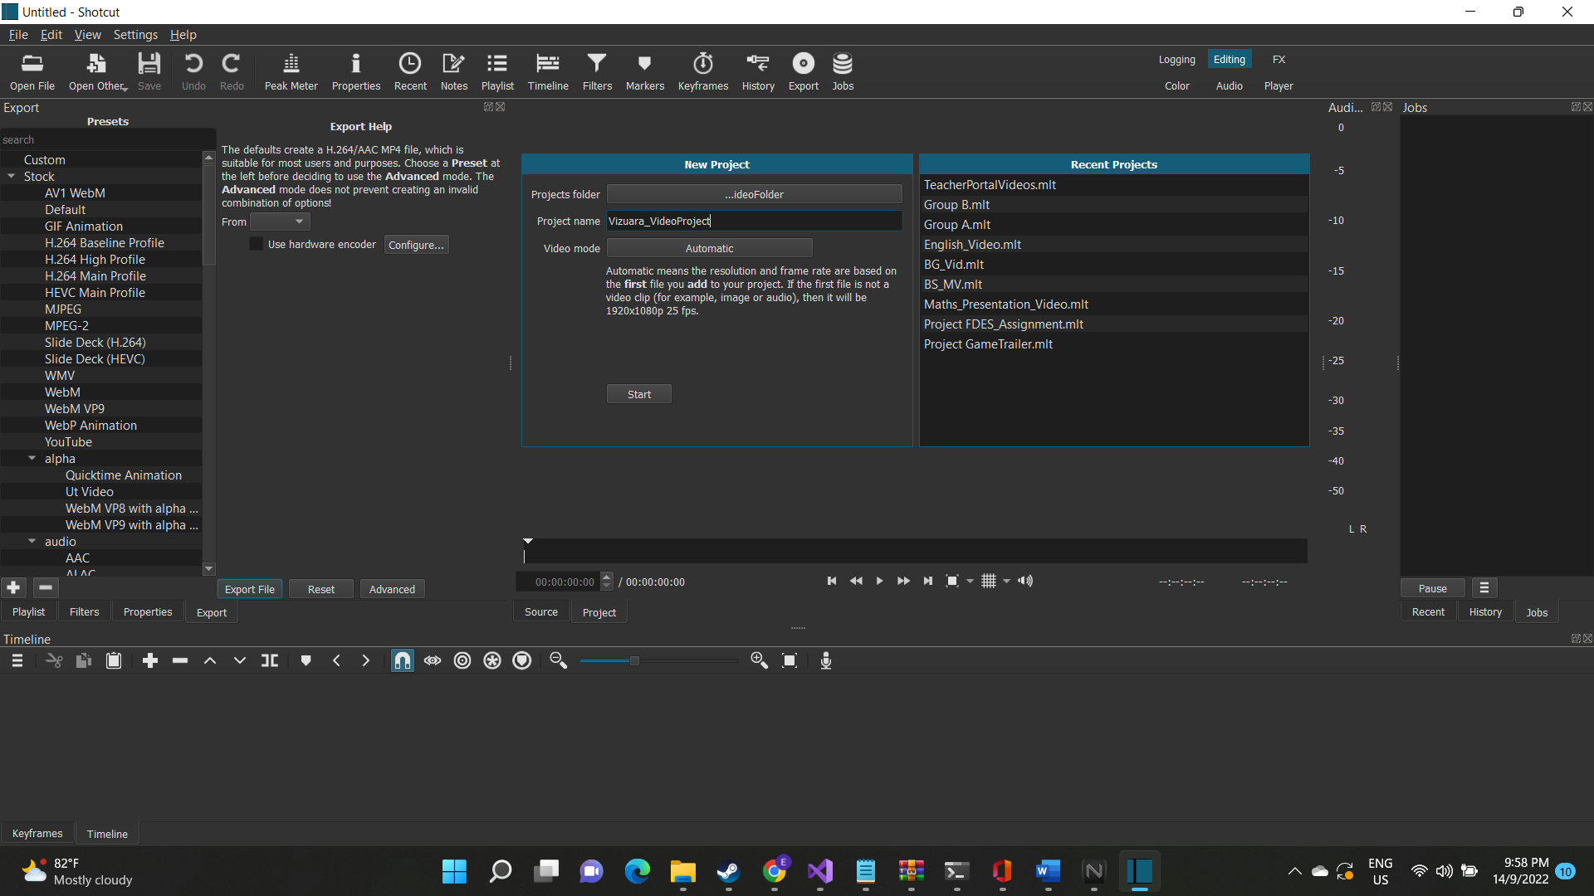

After that, click on playlist at the top of menu bar around in the middle to open up the playlist window in shotcut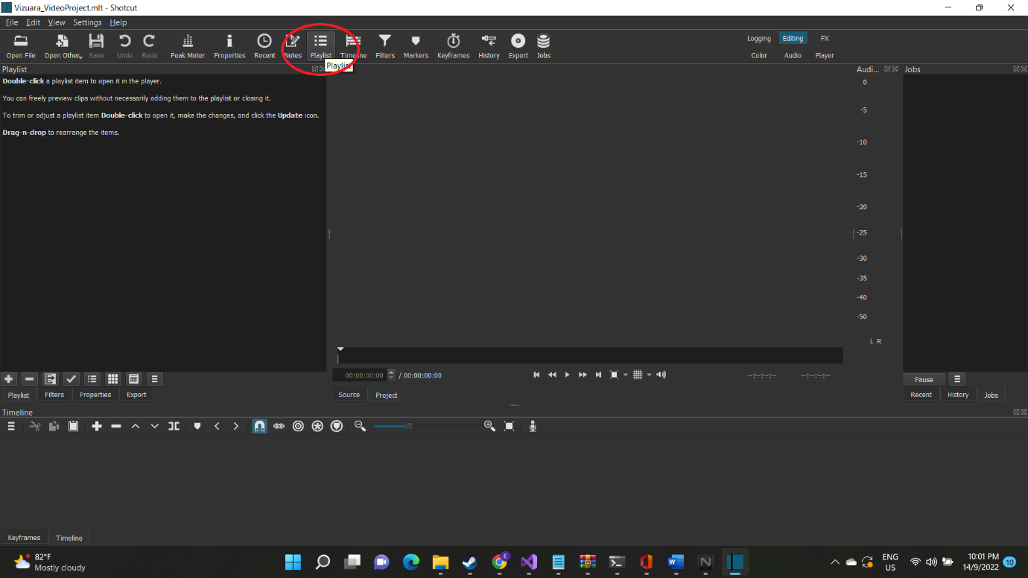

Then click on “Open File” at the top left side of the menu bar, to open up the file explorer

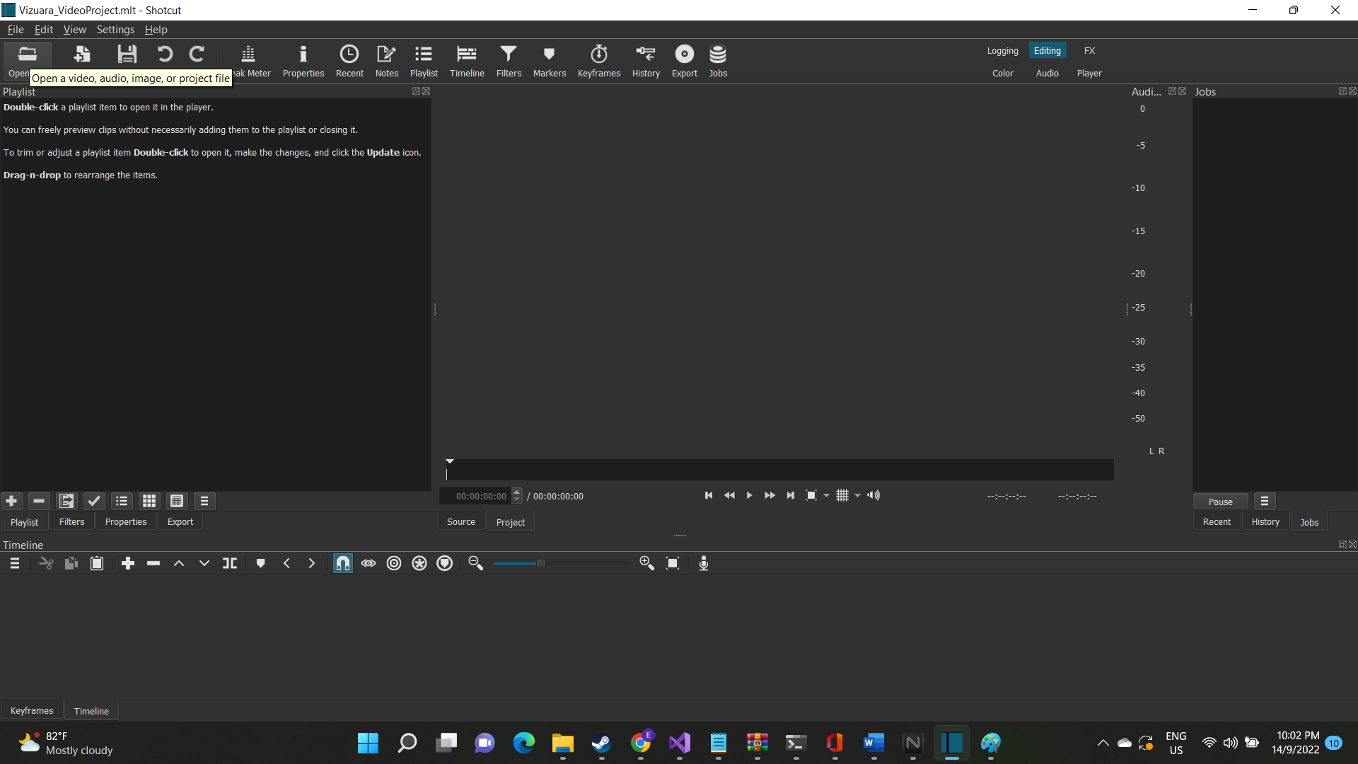

After that, navigate the file explorer to the folder that contains the videos that you want to edit and convert.

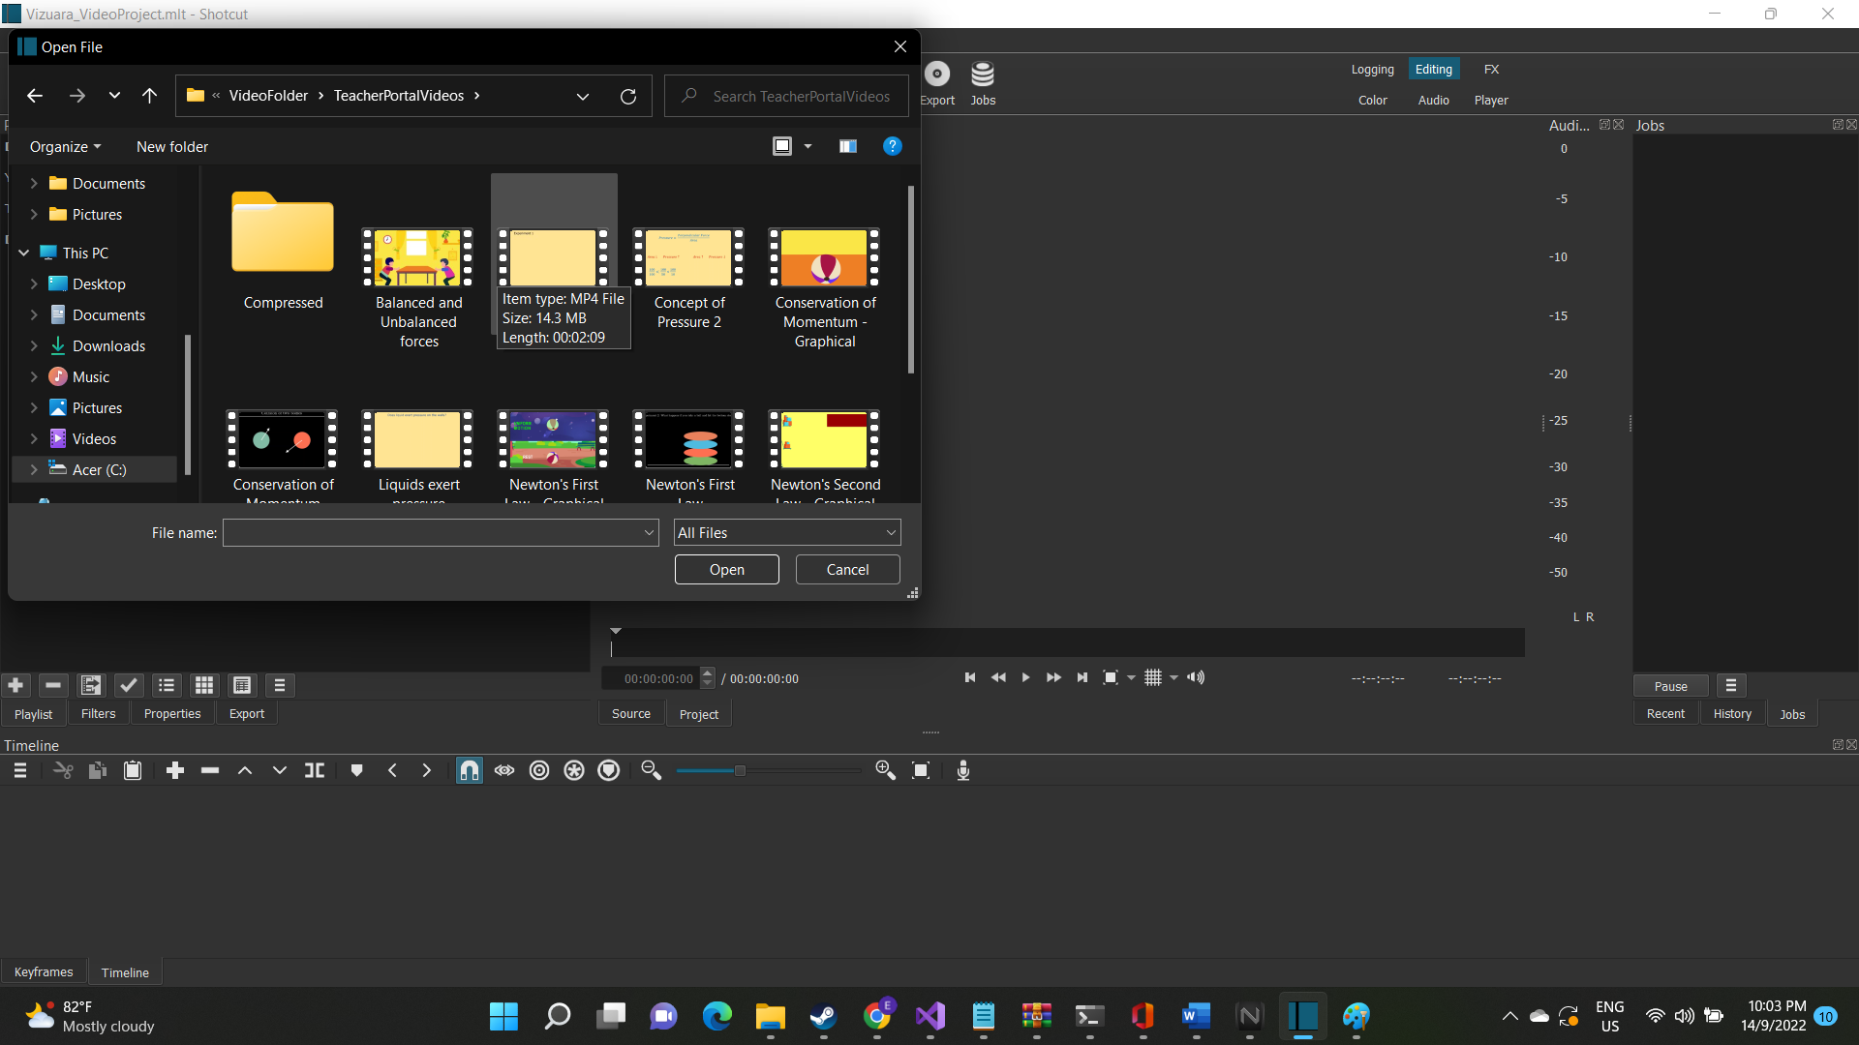

Select all the videos you want to edit by holding “Left-Shift” and clicking on each individual videos you want to edit.

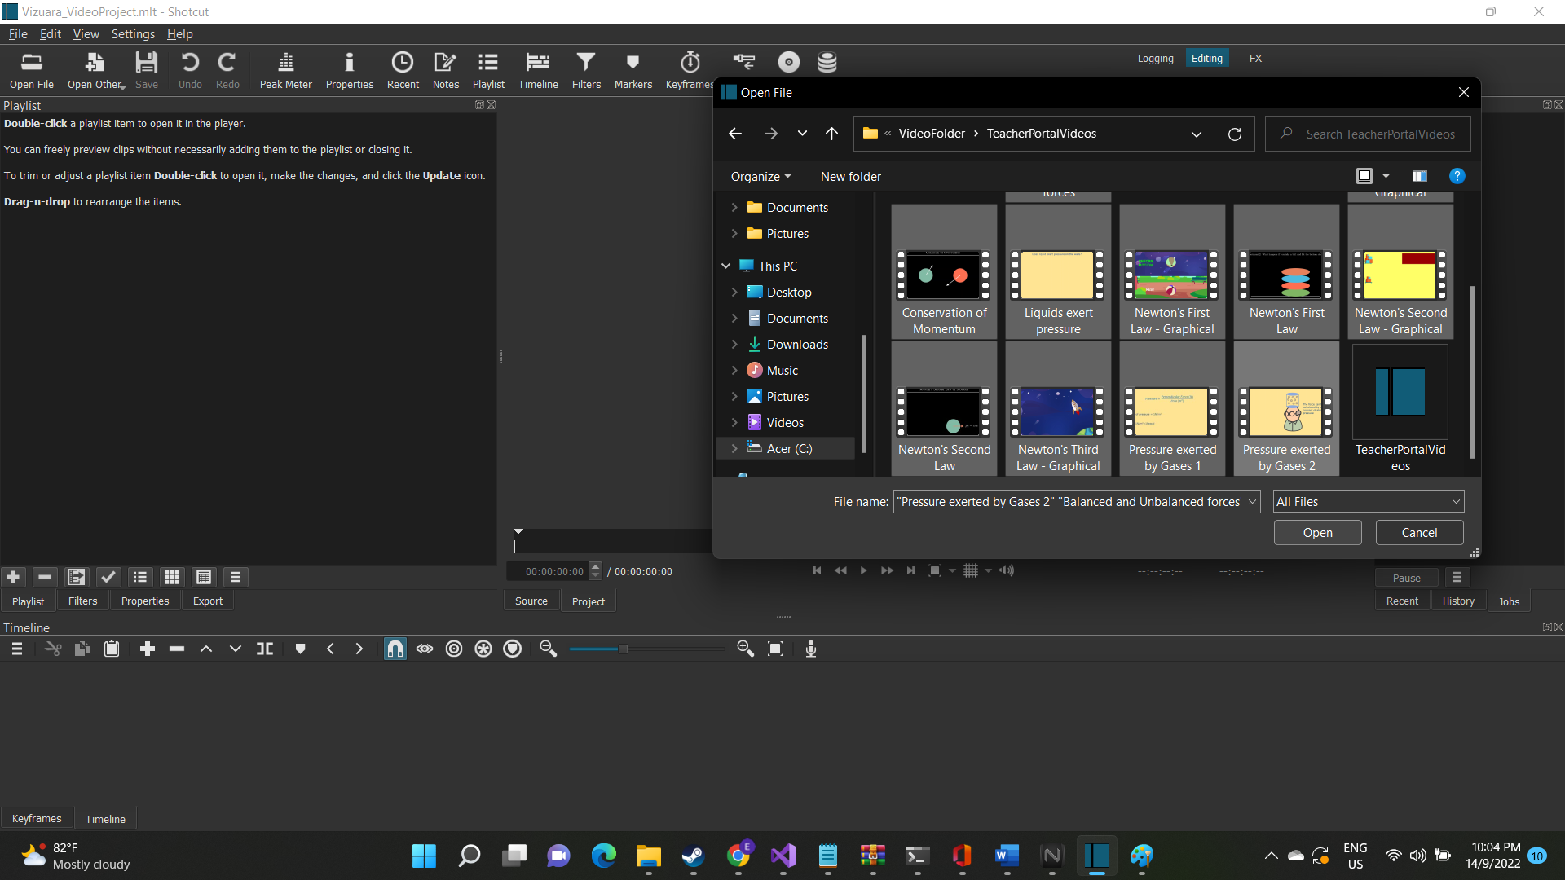

After that, click open and you will be able to see the videos will be available inside Shotcut.

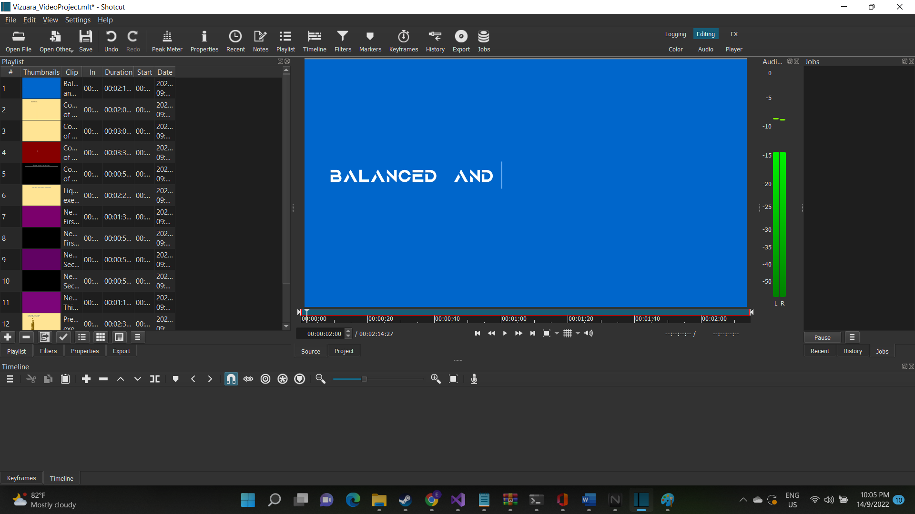

After the videos are imported, you might see one of the videos start playing all of a sudden. You can pause it by click on pause below the video displayer. After that, starting from the top, you can drag and drop individual videos into the Timeline component at the bottom of the screen. 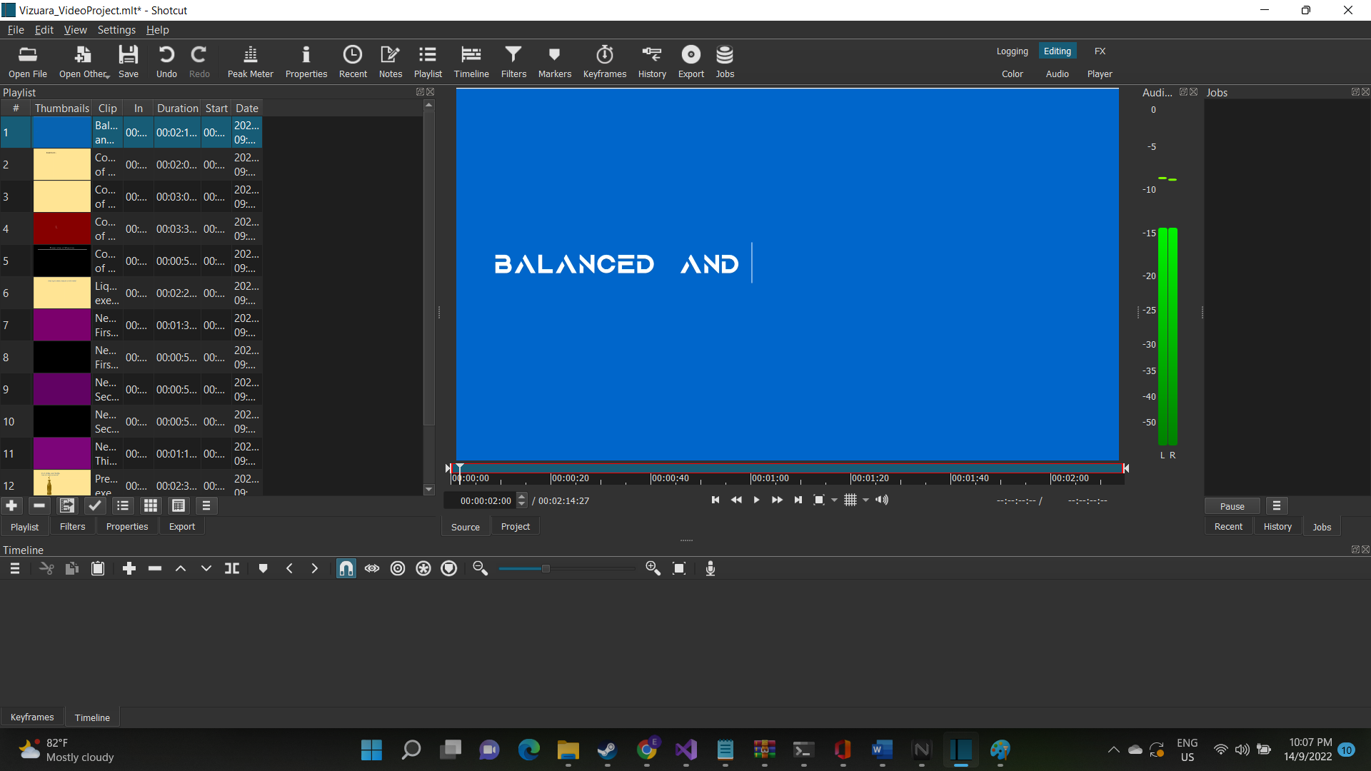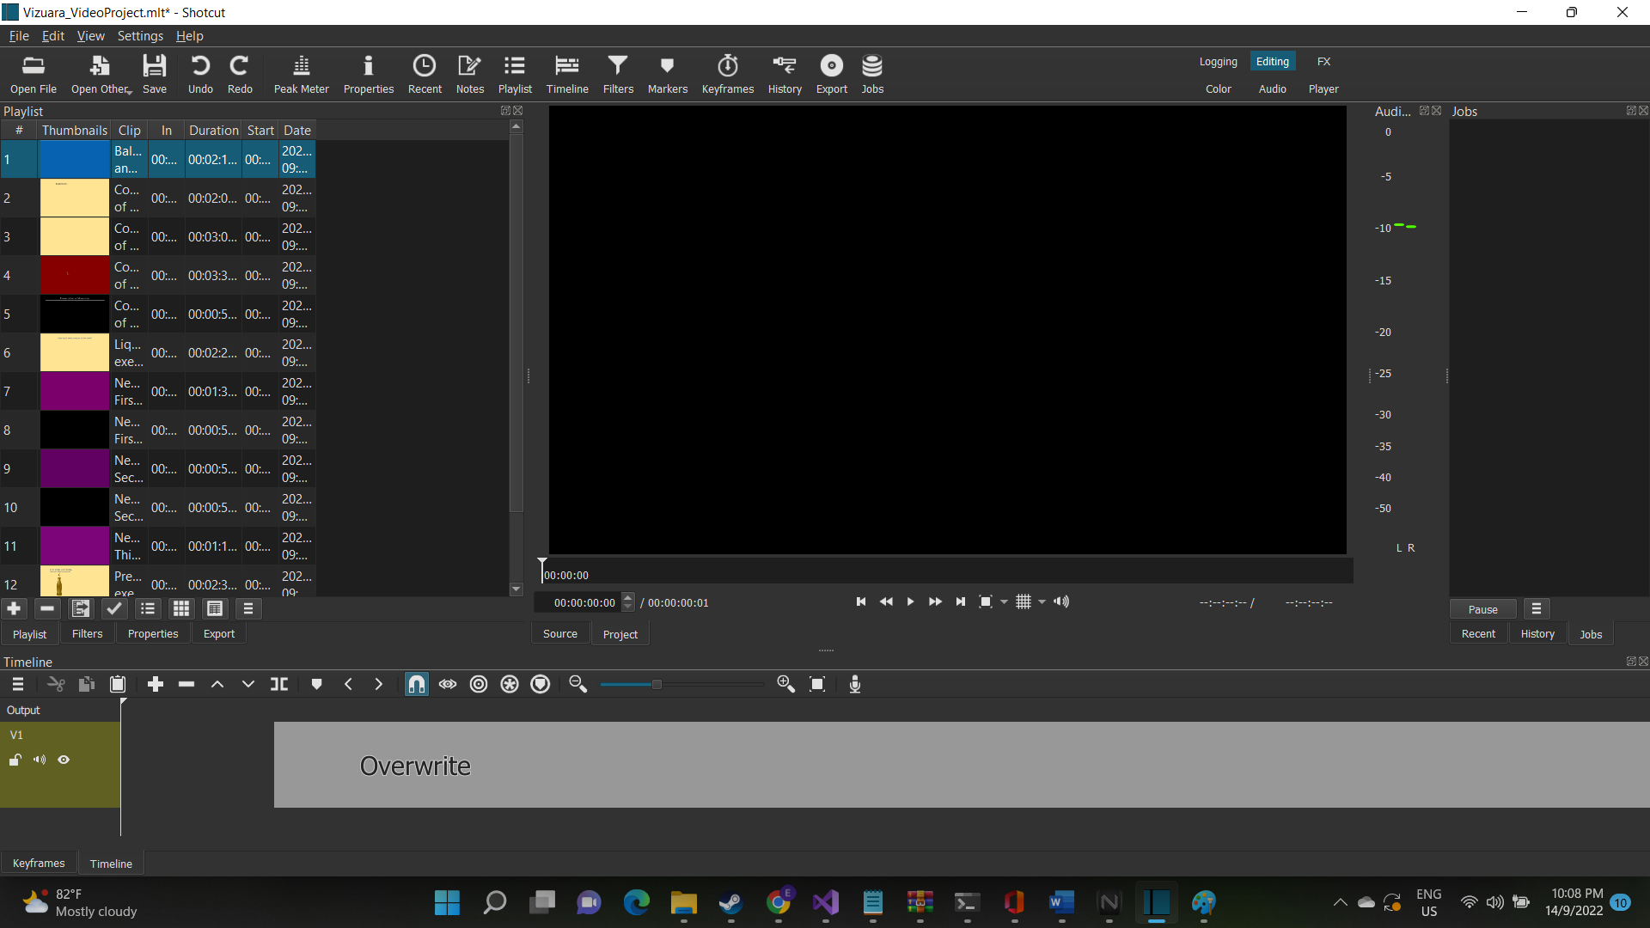

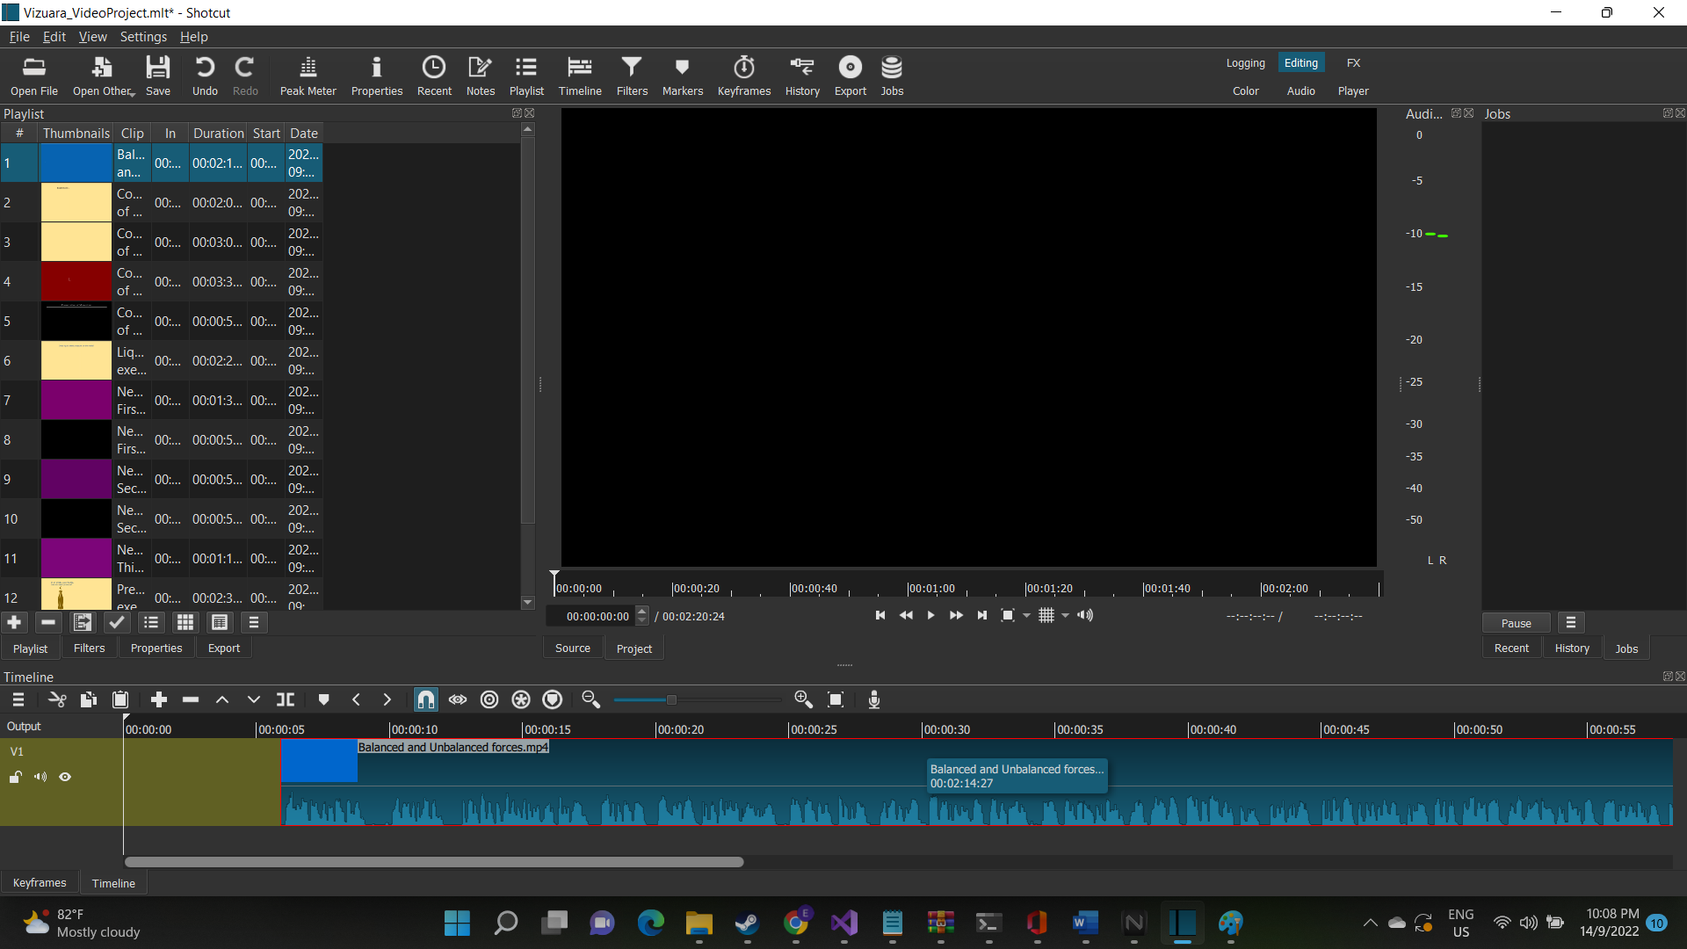

Make sure the beginning of the video is at the 00:00 mark, since only then there will be no black screen at the beginning of the video. What you can do, is that you drag the video to the 00:00 mark.

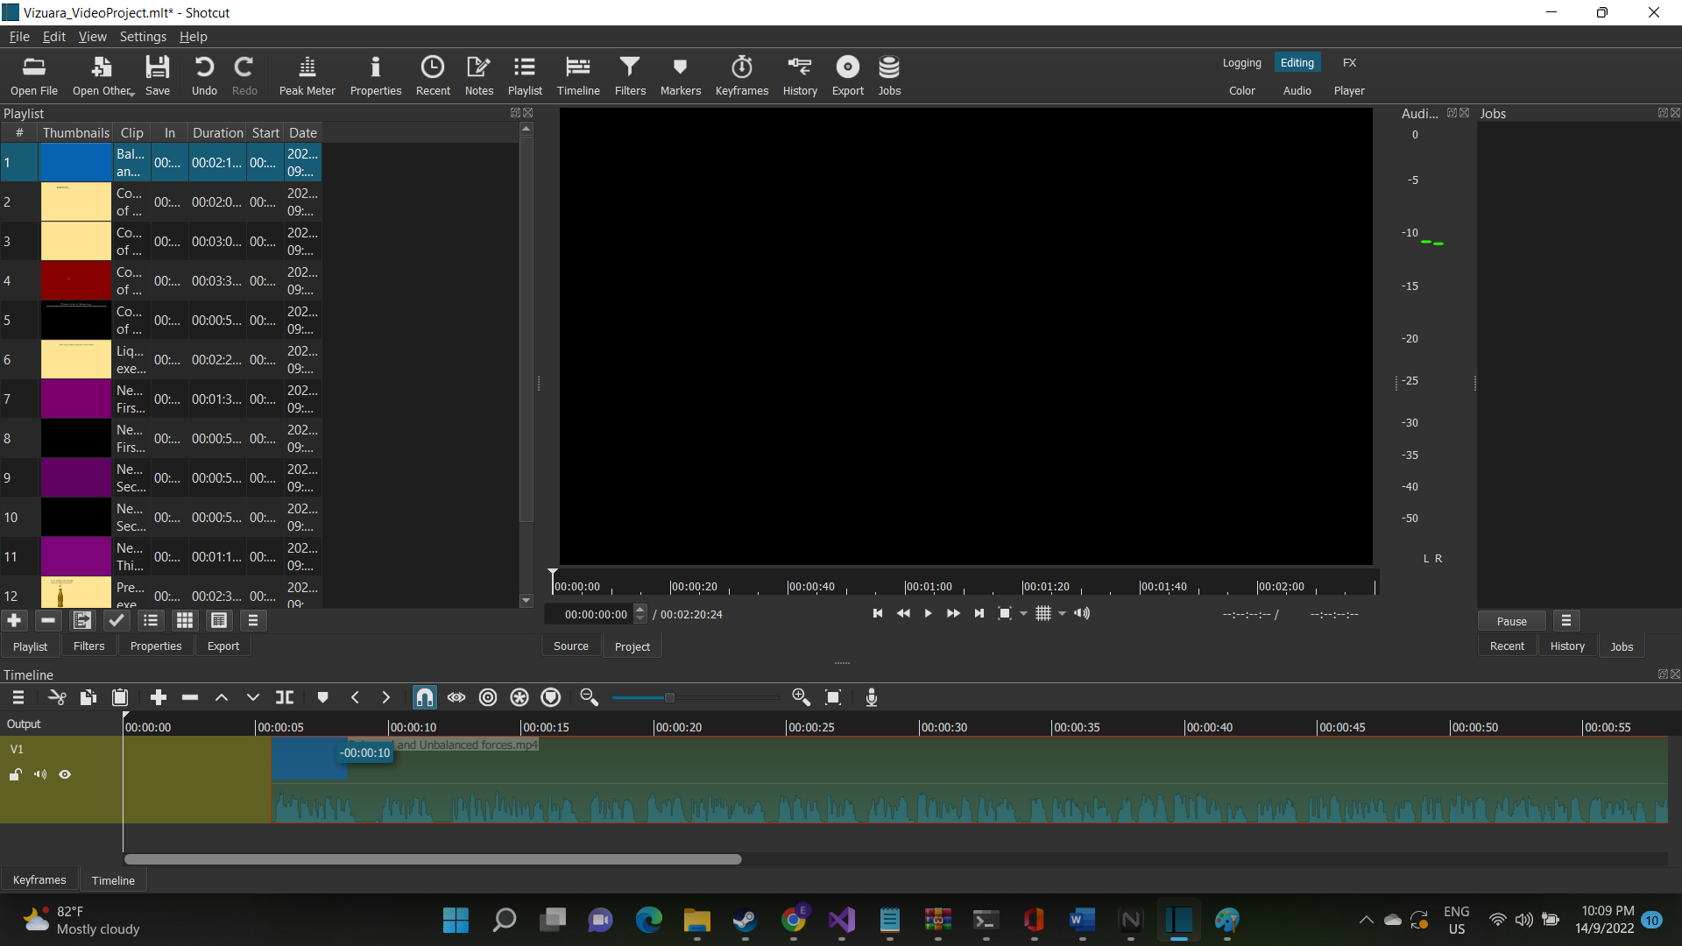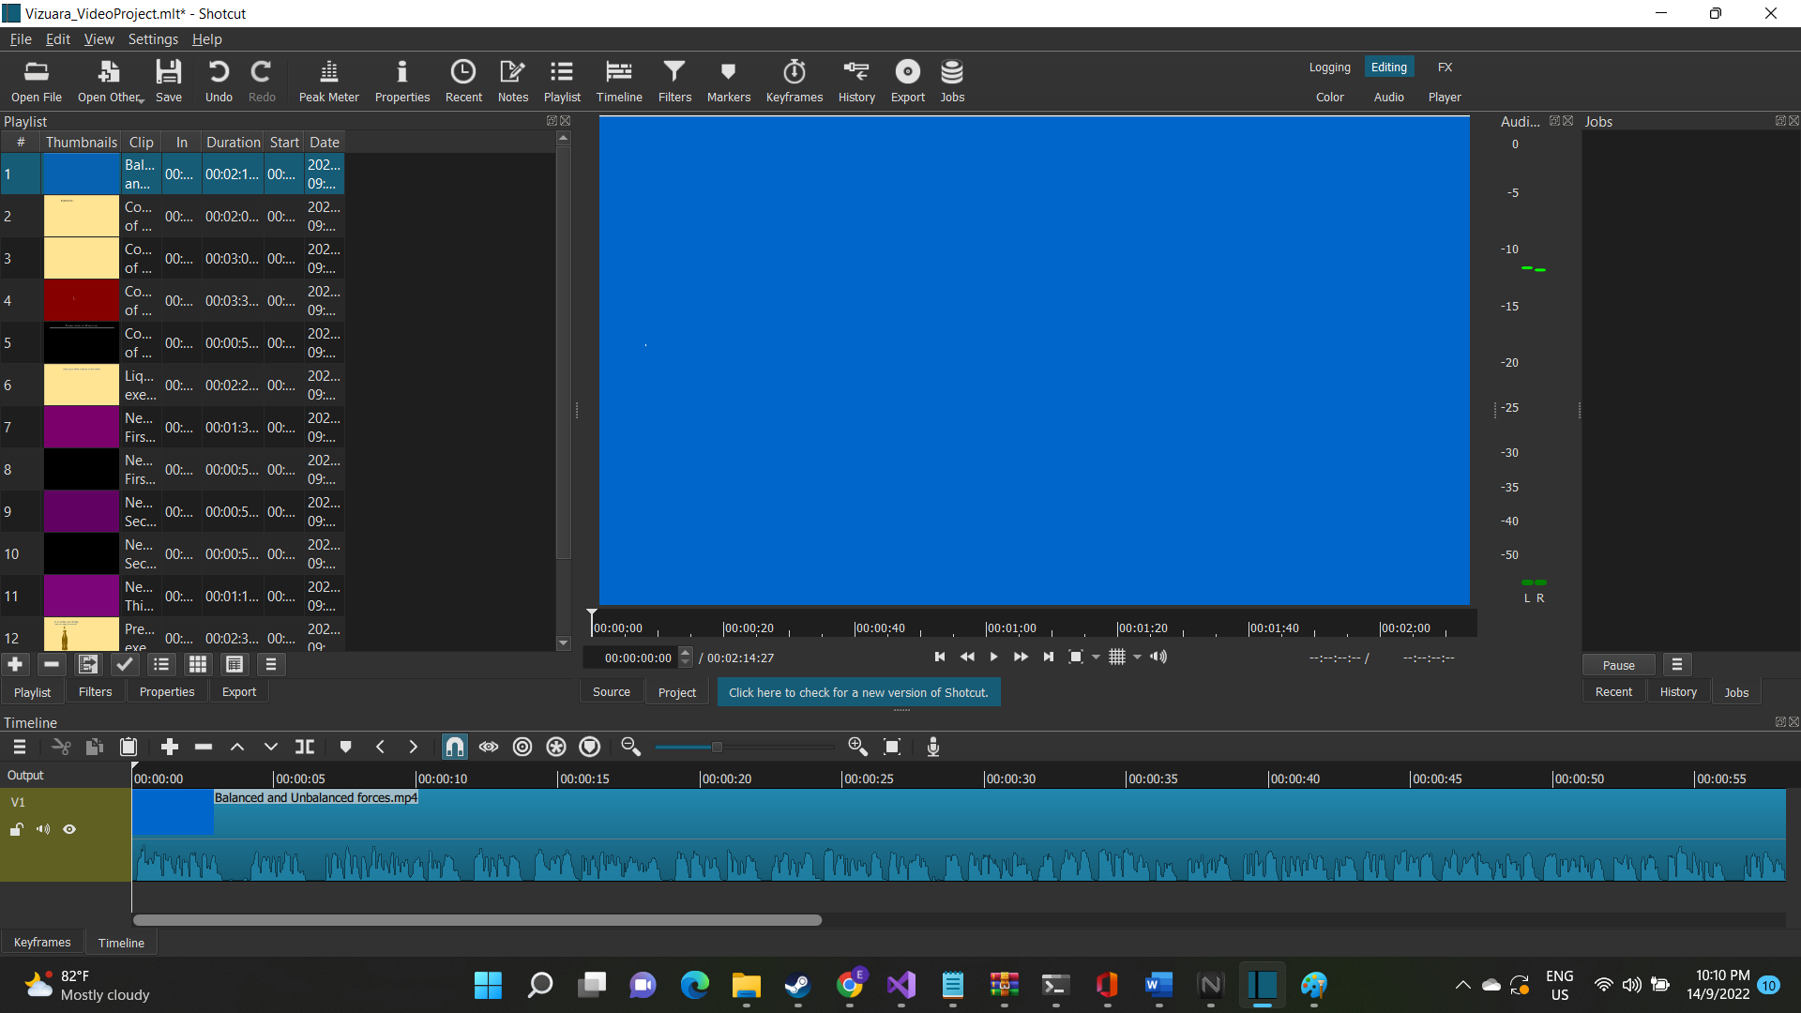

After this, you click on the export button at the top middle bar, to start editing and converting the video.  
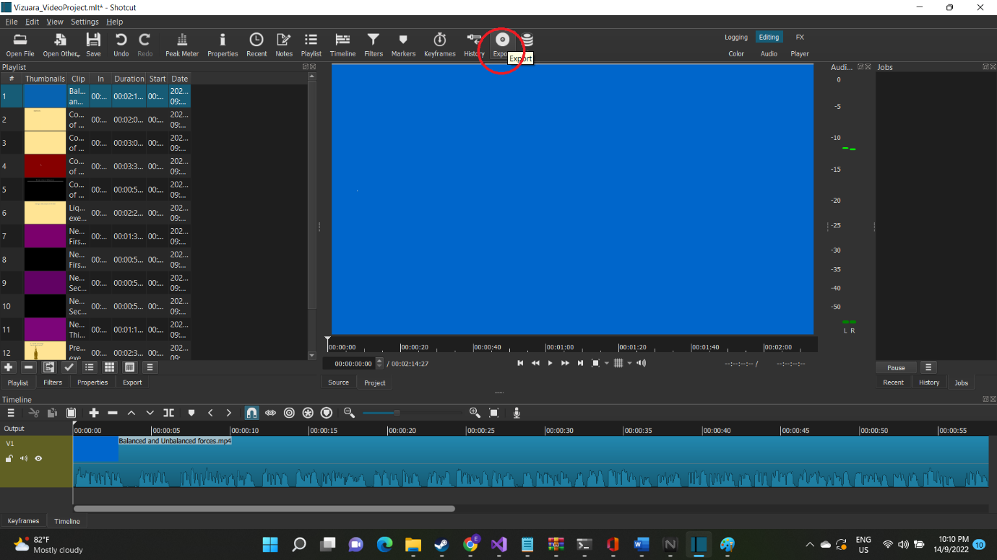

After the export window has been opened, click on the Advanced button in the export window as seen in the picture  
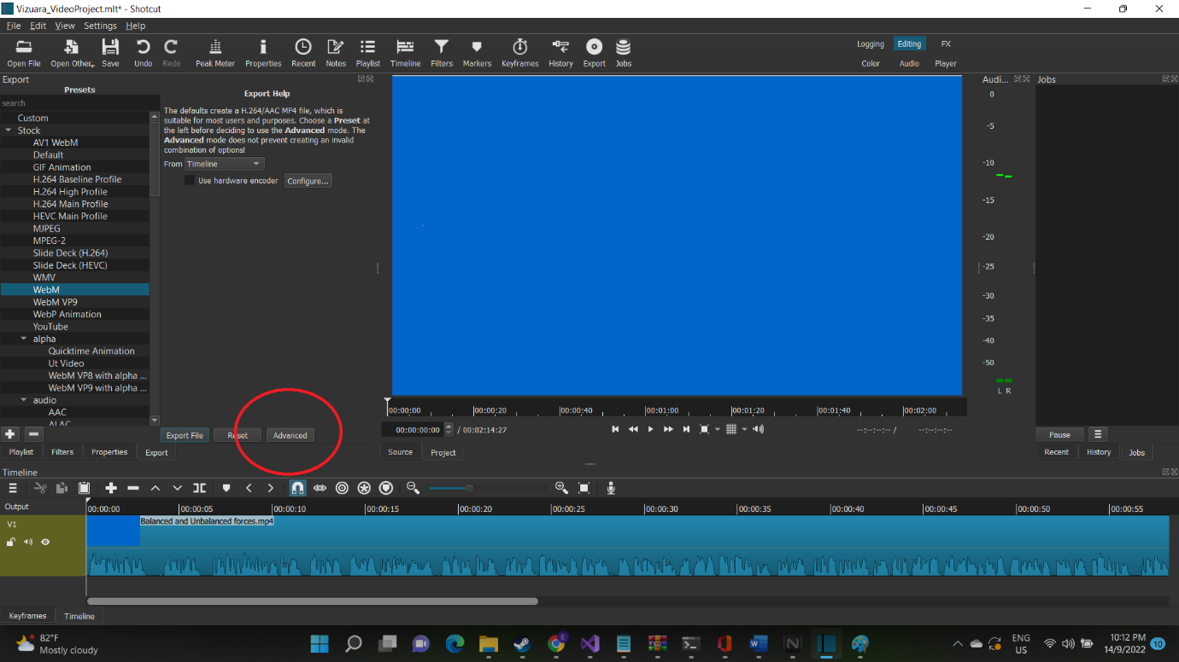

After that, you would see various settings appearing, adjust it so that the settings looks like this  
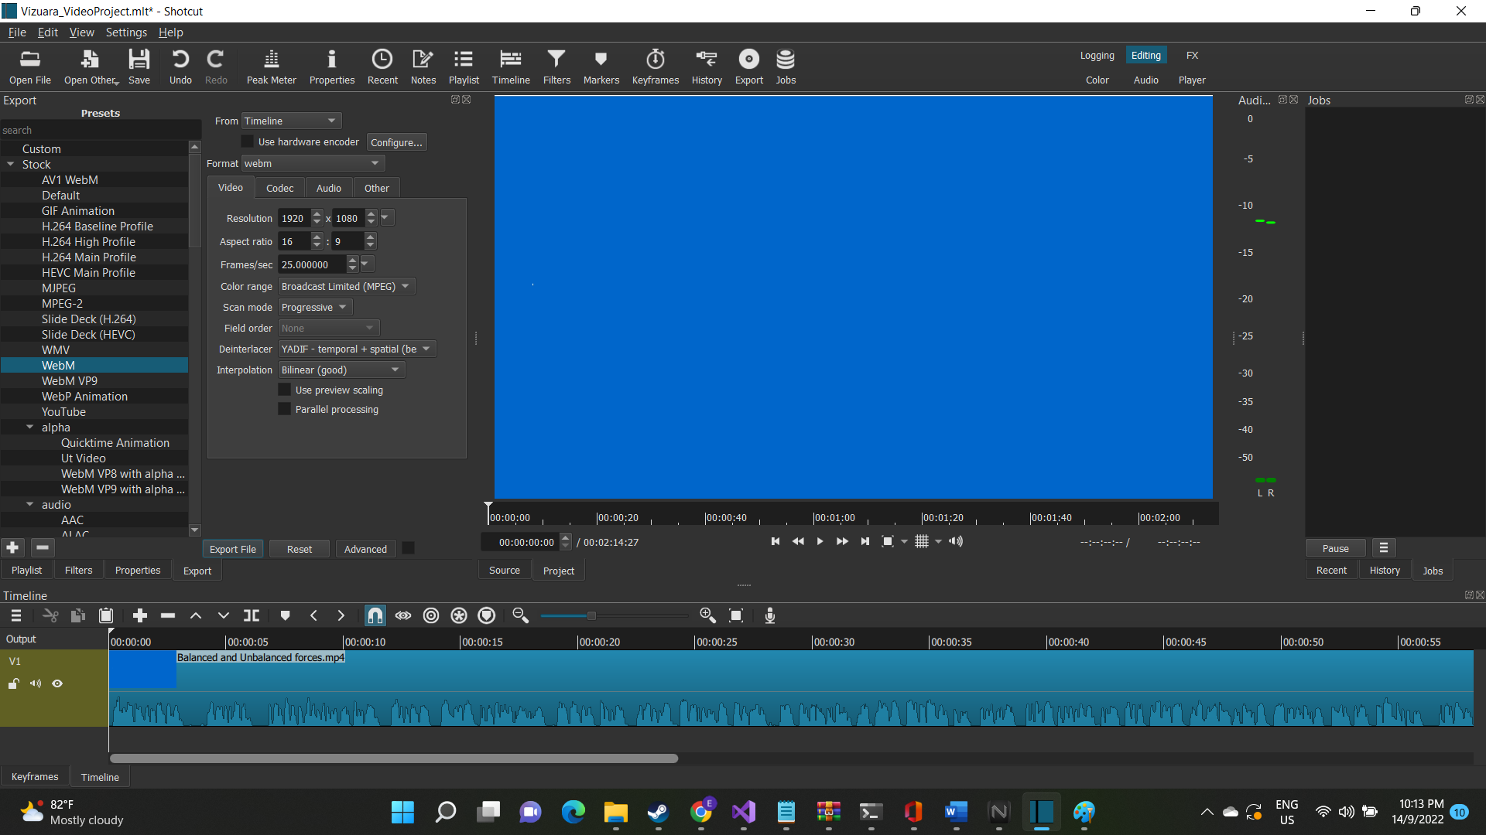  
Then, select WebM at the left side of the Export tab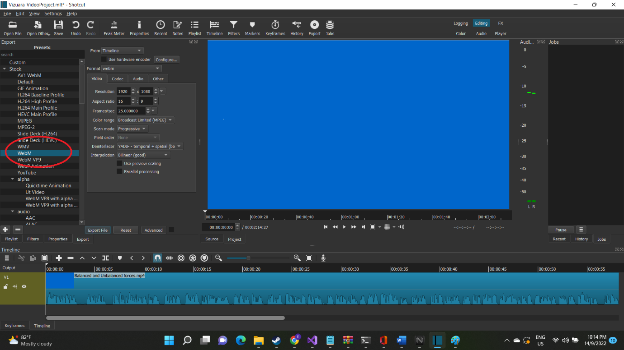

After that, click on export file to start exporting  
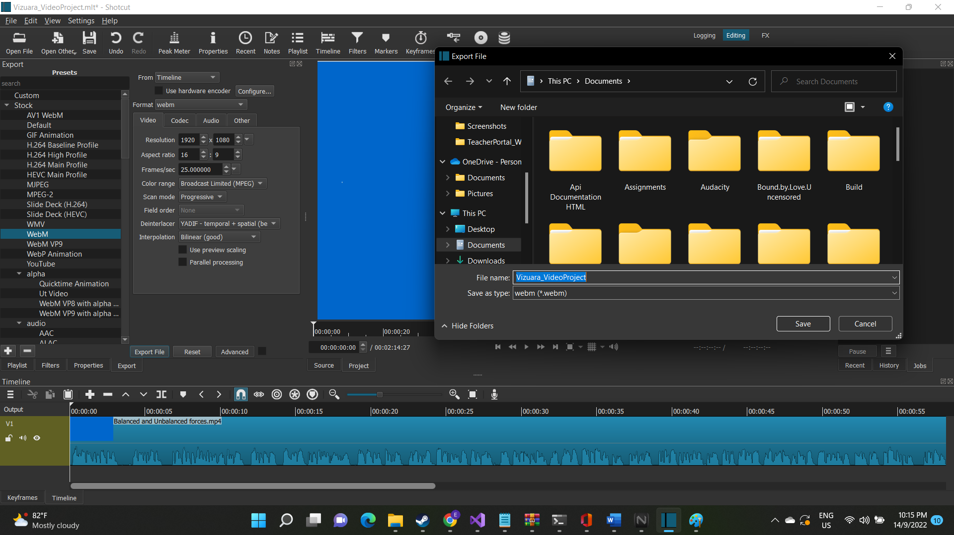  
Save the file somewhere you like and wait for the conversion process to finish  
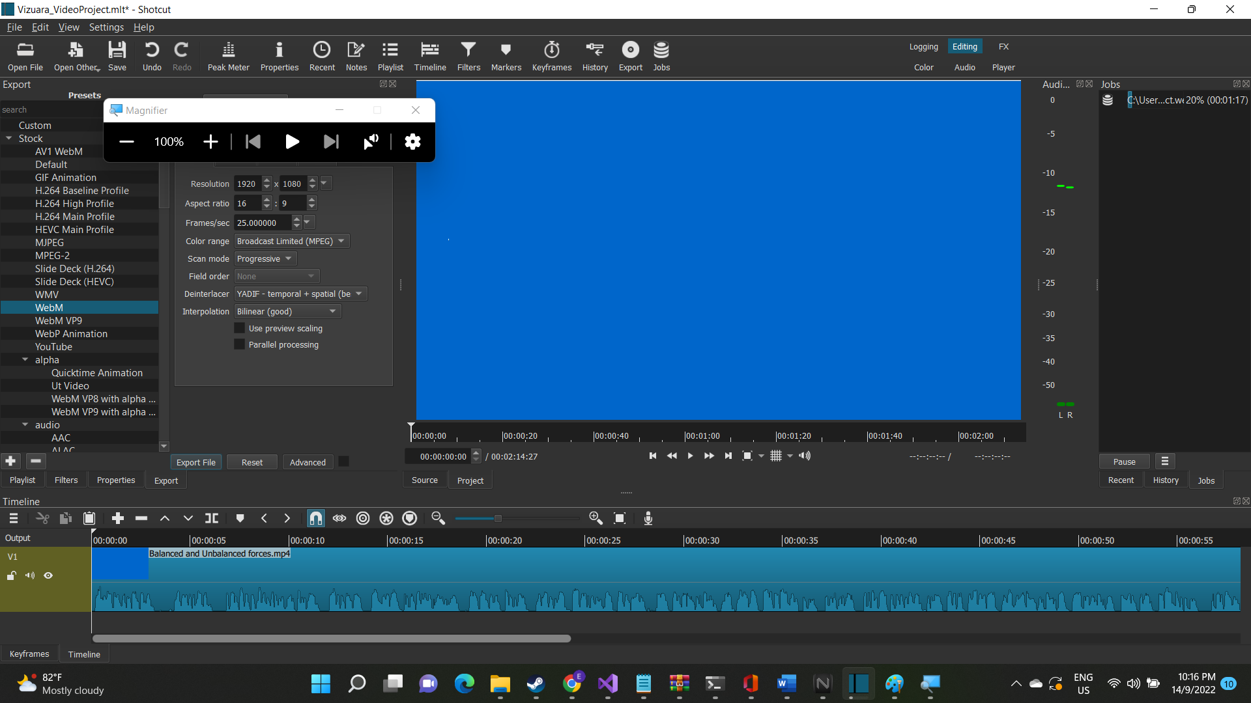

On the right side, you will be able to see the progress. It might take some time depending on how powerful your computer is. After it has completed, you can check the directory and see if the file actually exists or not. If yes, then we have just finished lowering the file size and changing the file format with just using one application.  
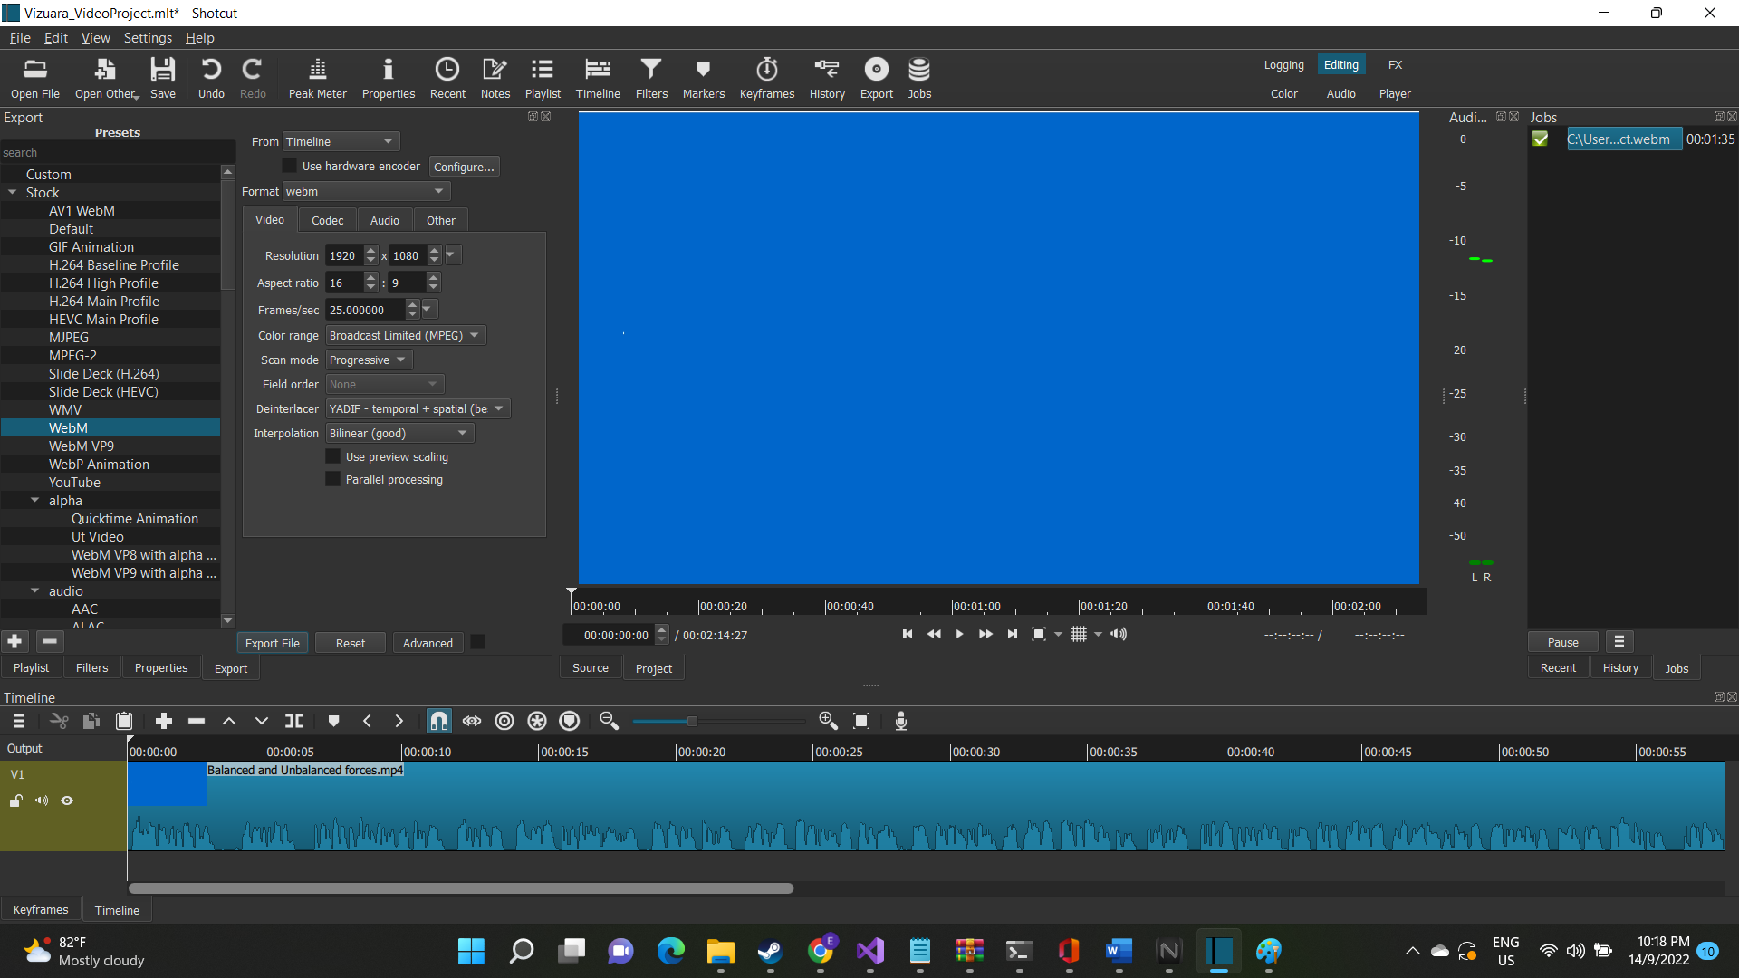

Then we will start over again, by deleting the video from the timeline, and add another video there.  
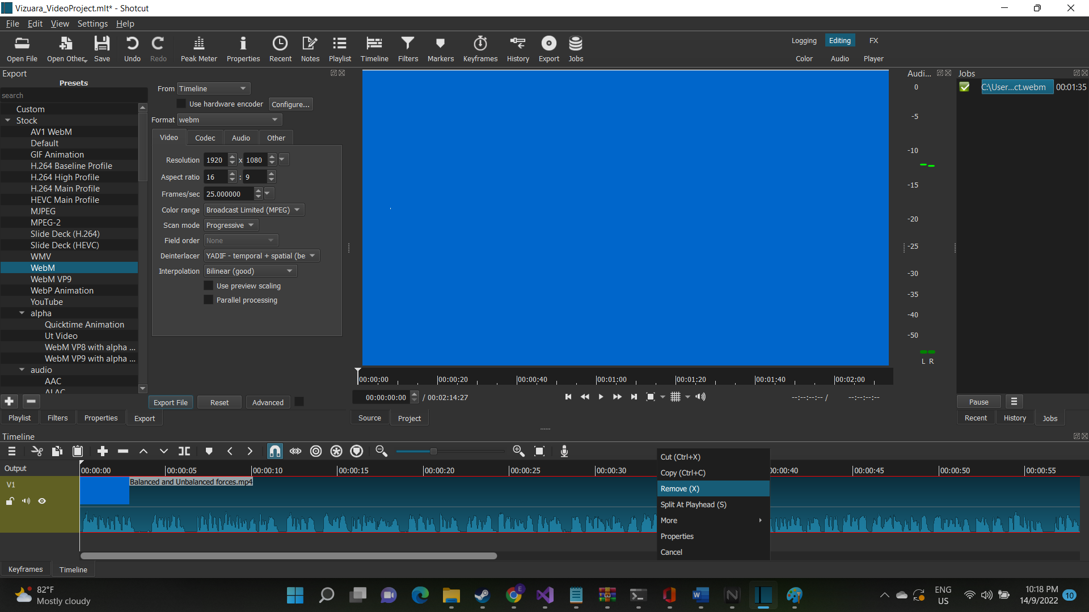

Right click on the video track, and click on “Remove”. That will clear the Timeline and we can start editing and converting another video  
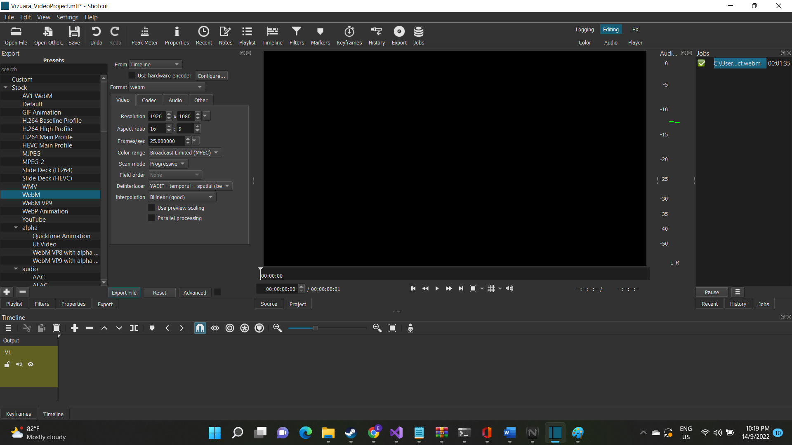

Now click on Playlist again to display the Videos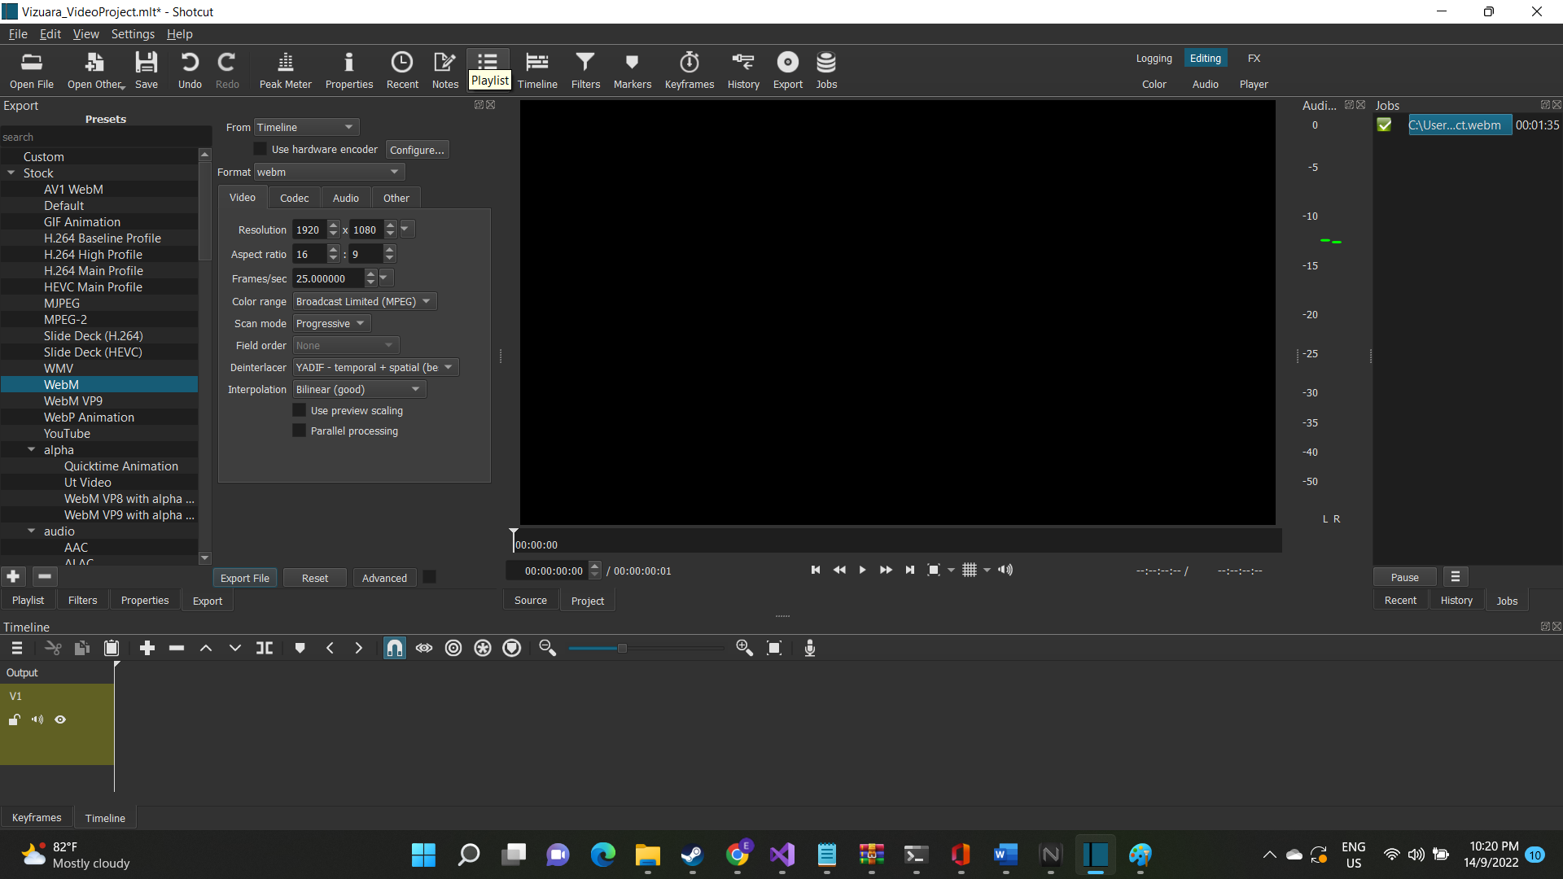

Right click on the video you have just edited and click Remove to remove the video from the list to avoid confusion.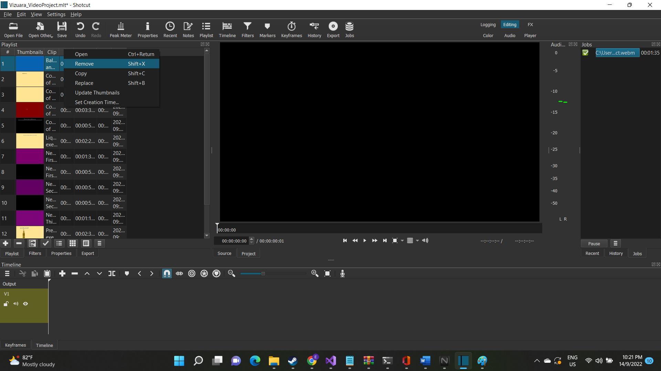Then the process repeats itself. Make sure that the files are actually saved in Webm format and their file size actually get lower.

**LABORATORIES**

For Laboratories, rename the exe file and its’ data folder so that the character count is very low. (There are some issues where the client application cannot open exe file with long names or names that include special characters)  
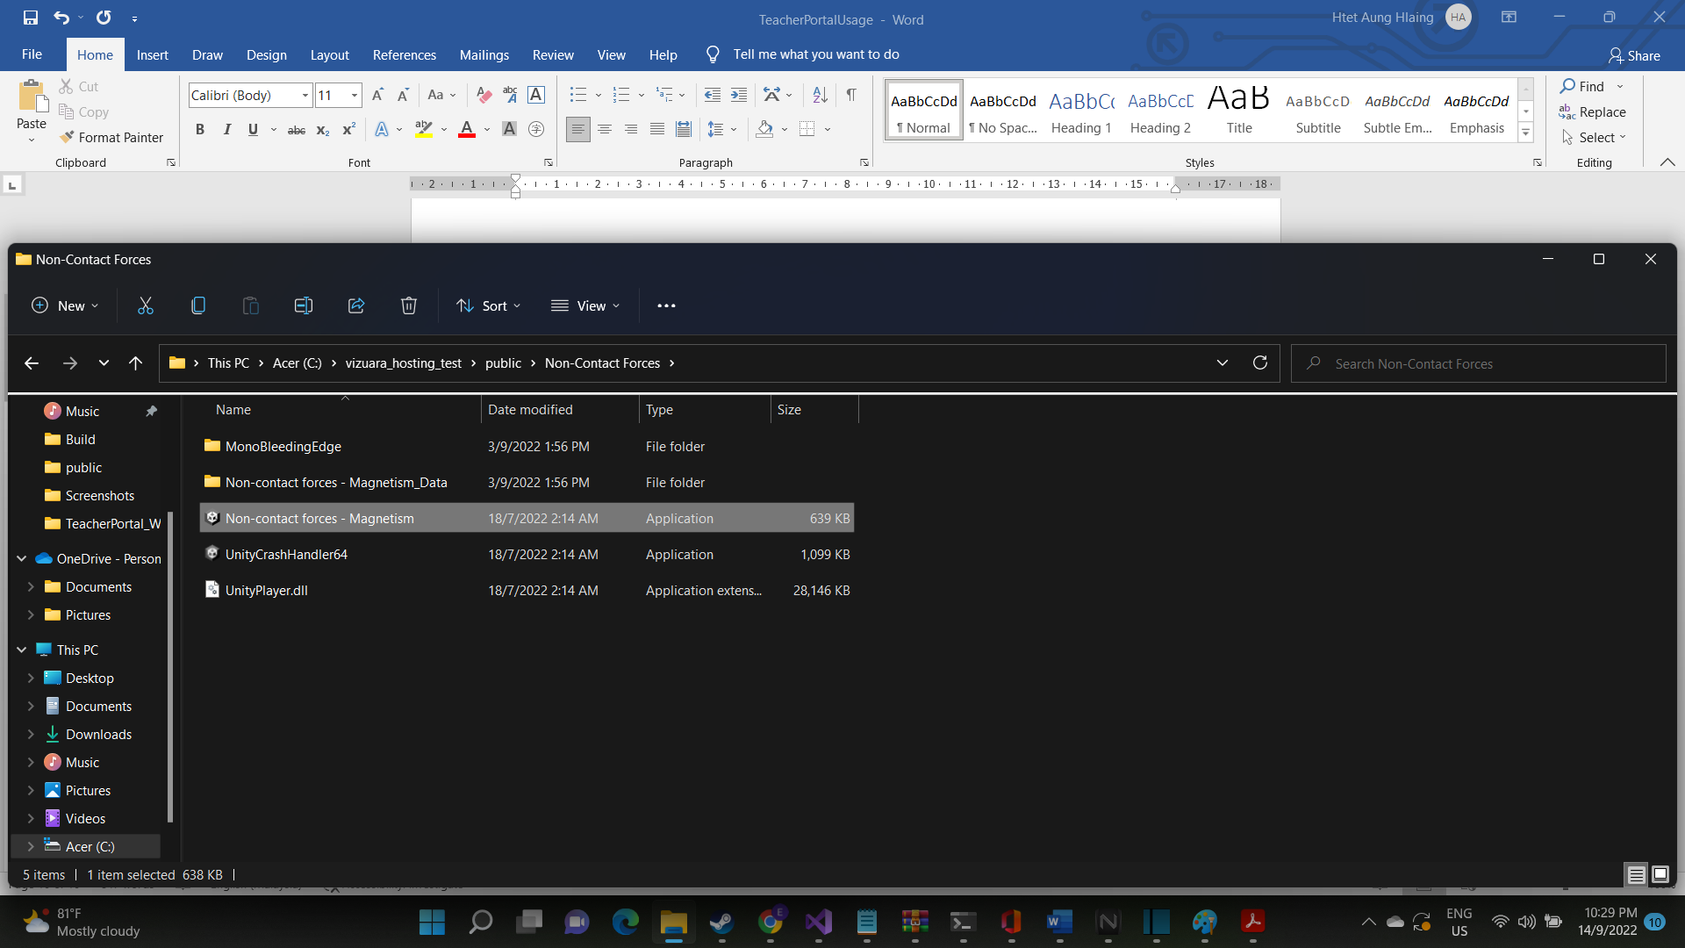  
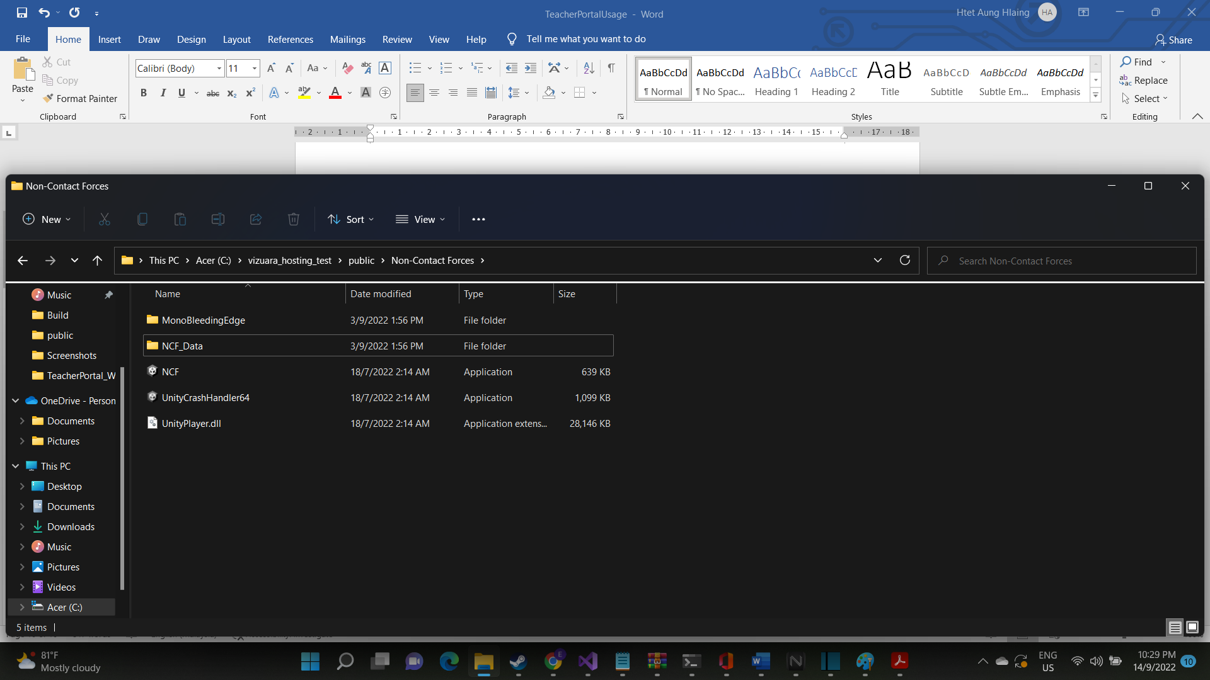  
The name that would be display on the application would be the folder name, so you can adjust it however you want.

**Pop Quizzes**

Pop Quizzes are stored in .vizdata format files which include the link to the website you want the in-app webview to redirect to.  
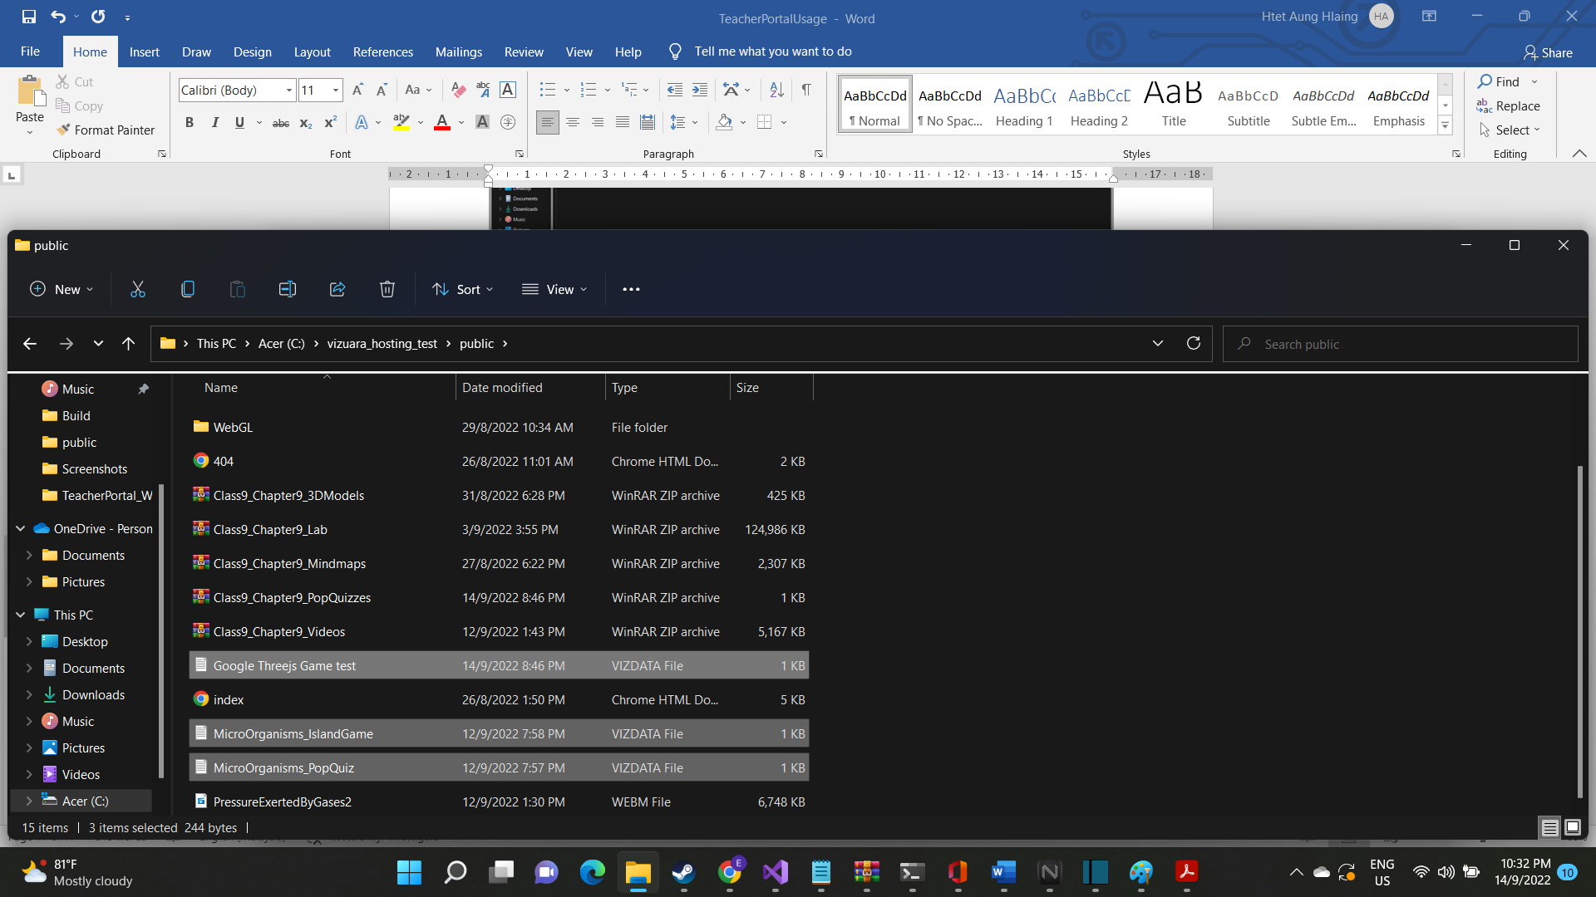

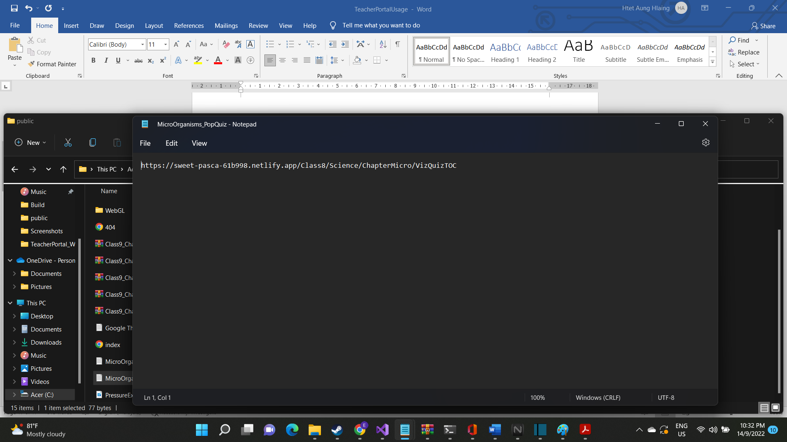

To create a .vizdata file is fairly simple. Open Notepad. And add your link. And then click on File -> Save as -> All Files and then while typing the name of the file, also add .vizdata in the end. The name of the file will be used to display in the application as well so you have to name this properly unlike laboratories exe files.

**3D Models**

3D Models, that are needed to be displayed inside the client application must follow several rules. First off, it **MUST** be in .obj format as it is the only format that the 3D Displayer I developed support. There are several ways to convert other formats into .obj format. But we will talk about this later.

The 3D model file and its texture file MUST share the same name, otherwise the 3D Displayer Application wouldn’t be able to find the texture and display correctly. 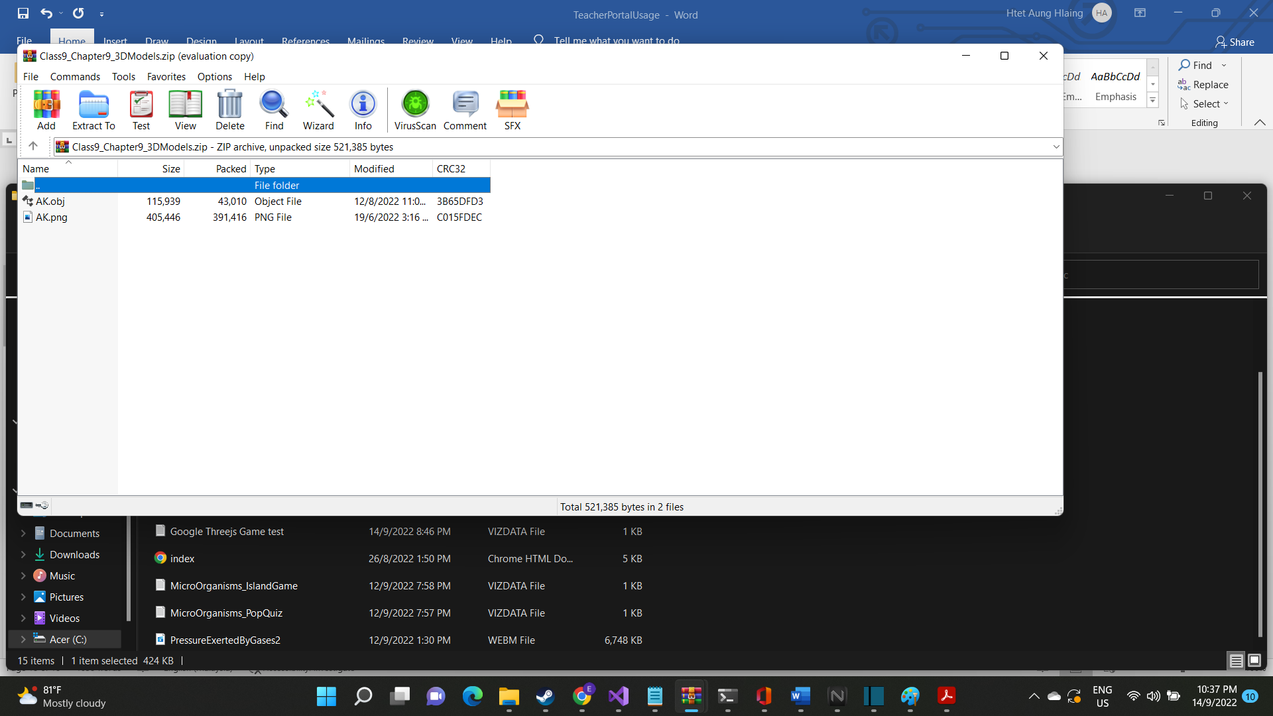

And they must be placed inside the same folder. Other than this, there is nothing too much to do regarding with 3D Models

**Mindmap**

No need changes for them at all.